

**Study Guide**

**Author**

**Srinivas Dande**



**www.coursecube.com** **1** **Spring-5 Study Guide**



**Spring Framework**

**The Spring Framework provides a comprehensive programming and configuration model for modern Java-based enterprise applications**

**Spring Framework is a Java platform that provides comprehensive infrastructure support for developing Java applications.**

**Spring handles the infrastructure so you can focus on your application.**

**Using Spring Framework,We can develop Large-Scale , Distributed High-Performance Applications**



**Spring Framework Modules**

**Module 1: Spring IOC**

**Module 2: Spring AOP**

**Module 3: Spring DAO Support.**

**Module 4: Spring with JDBC**

**Module 5: Spring with Hibernate**

**Module 6: Spring Transaction Management**

**Module 7: Spring Web MVC**

**Module 8: Spring Rest WebServices.**

**Module 9: Spring Security**

**Module 10: Spring with Java Mail**

**Spring Other Projects** 



1. **Spring Boot**
2. **Spring Data.**
3. **Spring Cloud**
4. **Spring Messaging**
5. **Spring AMQP**
6. **Spring Kafka**
7. **Spring Android.**
8. **Spring Batch**
9. **Spring Social.**
10. **Spring Web Flow.**
11. **Spring LDAP.**
12. **Spring Hadoop.**
13. **Spring Scala.**
14. **Spring Mobile.**
15. **Spring Roo.**



**www.coursecube.com** **2** **Spring-5 Study Guide**



**Spring IOC (Inversion Of Control)** 



**When you are developing any component or bean, it may contain some dependencies.**



|  |  |  |
| --- | --- | --- |
| **class A{** |  | **class Hello{** |
| **void m1(){ ... }** |  |  |
| **}** |  | **A aobj=null;** |
|  |  | **B bobj=null;** |
| **class B{** |  |  |
| **void m2(){ ... }** |  | **void show(){** |
| **}** |  | **aobj.m1();** |
|  |  | **bobj.m2();** |
|  | **}** | |
|  | **}** | |
|  |  |  |

**Hello Bean needs A object and B object.**

**Hello Bean needs A resource and B resource. Hello Bean needs A Bean and B Bean**

**Hello Bean is depending on two beans called A bean and B bean. Hello Bean dependencies called A and B has to be Initialized.**

**Hello Bean dependencies called A and B has to be Injected**

**Spring container Injects the Hello Bean dependencies called A and B.**

**Dependency Injection**

**Dependency Injection is the process of Injecting bean dependencies automatically. Spring Dependency Injection uses 3 ways to inject the dependencies**

* 1. **Setter Injection**
  2. **Constructor Injection**
  3. **Field Injection (using Annotations)**

**Ex:**

**class Student{**

**String sid;**

**//1 Setter Injection**

**String sname;**

**//2 Constructor Injection**

**@Autowired**

**Address add;**

**//3 Field Injection.( using Annotations)**

**public void setSid(String sid){**

**this.sid=sid;**

**//1 Setter Injection**

**}**

**public Student(String sname){**

**this.sname=sname;** **//2 Constructor Injection**

**}**

**}**



**www.coursecube.com** **3** **Spring-5 Study Guide**



**Download the Spring Jars**

1. **Open this url https://repo.spring.io/release/org/springframework/spring/**
2. **Click on 5.2.5.RELEASE**
3. **Click ON spring-5.2.5.RELEASE-dist.zip ... It dowloads the ZIP**
4. **Unzip the spring-5.2.5.RELEASE-dist.zip then you will see the folder called spring-framework-5.2.5.RELEASE**
5. **You can see 63 Jars under libs**
6. **These 63 jars as belongs 3 groups**
   1. **21- binary jars (We need this only)**
   2. **21-source jars**
   3. **21 - java doc jars**
7. **Copy 21-Binary Jars into required Folder to use in your Eclipse Projects.**



**First Spring Example Using Java Configuration**

1. **Open the Eclipse with Some Workspace.**
2. **Create the Java Project with the Name : Lab1**
3. **Add the JDK1.8 to Project.**
4. **Add 21 Spring-5 Jars to Project build path.**
5. **Create the Package called com.coursecube.spring**
6. **Write the following 3 Beans**
   1. **A.java**
   2. **B.java**
   3. **Hello.java**
7. **Write the Client Program without Spring**
   1. **Lab1A.java**
8. **Run Lab1A**
9. **Configuring the Beans in Configuration Class JLCAppConfig.java**
10. **Write the Client Program**
    1. **Lab1B.java**
11. **Run the Lab1B**

**Lab1: Files required**

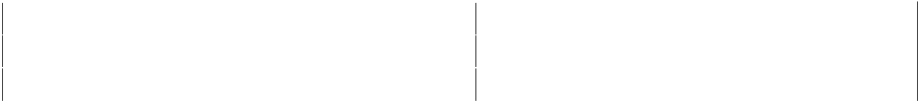

|  |  |  |  |  |
| --- | --- | --- | --- | --- |
| **1.** | **Lab1A.java** | **2.** | | **Lab1B.java** |
|  |  |  |  |  |
| **3.** | **A.java** | **4.** | | **B.java** |
|  |  |  |  |  |
| **5.** | **Hello.java** | **6.** | | **JLCAppConfig.java** |
|  |  |  |  |  |



**www.coursecube.com** **4** **Spring-5 Study Guide**

**1. Lab1A.java**

**package com.coursecube.spring; /\***

* **@Author : Srinivas Dande**
* **@Company : CourseCube**
* **@Website : www.coursecube.com**
* **\*/**

**public class Lab1A {**

**public static void main(String[] args) {**

**//Without Spring**

**//Task1 : Create and Initialize A object**

**A ao=new A();**

**ao.setA(101);**

**ao.setMsg("I am A");**

**//Task2 : Create and Initialize B object B bo=new B(102,"I am B");**

**//Task3 : Create and Initialize Hello object Hello h=new Hello(bo); h.setAobj(ao);**

**h.show();**

**}**

**}**

**2. Lab1B.java**



**package com.coursecube.spring;**

**import**

**org.springframework.context.ApplicationConte**

**xt;**

**import**

**org.springframework.context.annotation.Annot**

**ationConfigApplicationContext;**

**/\***

* **@Author : Srinivas Dande**
* **@Company : CourseCube**
* **@Website : www.coursecube.com**
* **\*/**

**public class Lab1B {**

**public static void main(String[] args) { //With Spring**

**ApplicationContext ctx=new**

**AnnotationConfigApplicationContext(JLCAppCo**

**nfig.class);**

**System.out.println("---------Now Spring**

**Container is Ready-----");**

* **aobj=(A)ctx.getBean("createA");**

**System.out.println(aobj);**

* **bobj=(B)ctx.getBean("BO");**

**System.out.println(bobj);**

**Hello h=(Hello)ctx.getBean("myhello"); h.show();**

**}**

**}**



**www.coursecube.com** **5** **Spring-5 Study Guide**

**3. A.java**

**package com.coursecube.spring; /\***

* **@Author : Srinivas Dande**
* **@Company : CourseCube**
* **@Website : www.coursecube.com**
* **\*/**

**public class A {**

**int a; //S.I**

**String msg; //S.I**

**static {**

**System.out.println("A - S.B");**

**}**

**public A() {**

**System.out.println("A - D.C");**

**}**

**public void setA(int a) { System.out.println("A - setA()"); this.a = a;**

**}**

**public void setMsg(String msg) { System.out.println("A - setMsg()"); this.msg = msg;**

**}**

**public String toString() { return ""+a +"\t"+msg;**

**}**

**}**

**4. B.java**



**package com.coursecube.spring; /\***

* **@Author : Srinivas Dande**
* **@Company : CourseCube**
* **@Website : www.coursecube.com**
* **\*/**

**public class B {**

**int b; //C.I**

**String str; //C.I**

**static {**

**System.out.println("B - S.B");**

**}**

**public B(int b, String str) { System.out.println("B - 2 arg"); this.b = b;**

**this.str = str;**

**}**

**public String toString() { return ""+b+"\t"+str;**

**}**

**}**



**5. Hello.java**

**package com.coursecube.spring;**

**/\***

* **@Author : Srinivas Dande**
* **@Company : CourseCube**
* **@Website : www.coursecube.com**
* **\*/**

**public class Hello {**

**A aobj; //S.I**

**B bobj; //C.I**

**static {**

**System.out.println("Hello - S.B");**

**}**

**public Hello(B bobj) {**

**System.out.println("Hello(B) - 1arg");**

**this.bobj = bobj;**

**}**

**public void setAobj(A aobj) {**

**System.out.println("Hello-setAobj()");**



**www.coursecube.com** **6** **Spring-5 Study Guide**

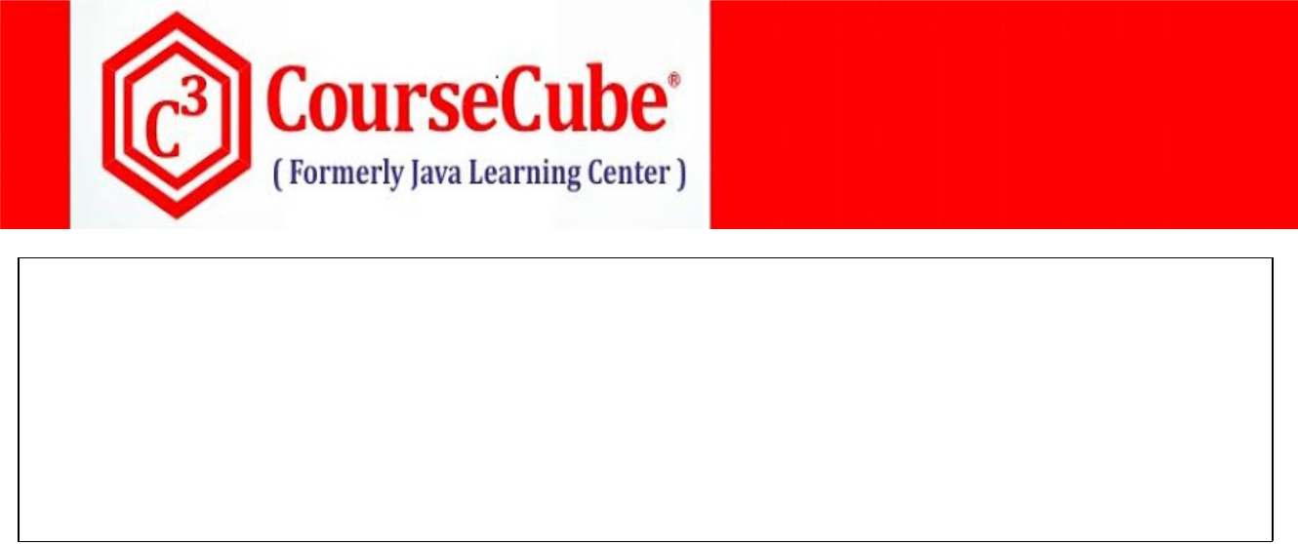

**this.aobj = aobj;**

**}**

**public void show() {**

**System.out.println("Hello-show()");**

**System.out.println(aobj);**

**System.out.println(bobj);**

**}**

**}**



1. **JLCAppConfig.java package com.coursecube.spring;**

**import org.springframework.context.annotation.Bean;**

**import org.springframework.context.annotation.Configuration; /\***

* **@Author : Srinivas Dande**
* **@Company : CourseCube**
* **@Website : www.coursecube.com**
* **\*/**

**@Configuration**

**public class JLCAppConfig {**

**@Bean**

**public A createA() {**

**//Task1 : Create and Initialize A object**

**A ao=new A();**

**ao.setA(101);**

**ao.setMsg("I am A");**

**return ao;**

**}**

**@Bean("BO")**

**public B createB() {**

**//Task2 : Create and Initialize B object**

**B bo=new B(102,"I am B");**

**return bo;**

**}**

**@Bean("myhello")**

**public Hello createHello(A ao,B bo) {**

**//Task3 : Create and Initialize Hello object**

**Hello h=new Hello(bo);**

**h.setAobj(ao);**

**return h;**

**}**

**}**



**www.coursecube.com** **7** **Spring-5 Study Guide**



**Bean Scopes**

**Bean Instance created by Spring Container can be in one of the following Scopes(Updated from Spring5).**

* 1. **singleton**
  2. **prototype**
  3. **request**
  4. **session**
  5. **application**
  6. **websocket**

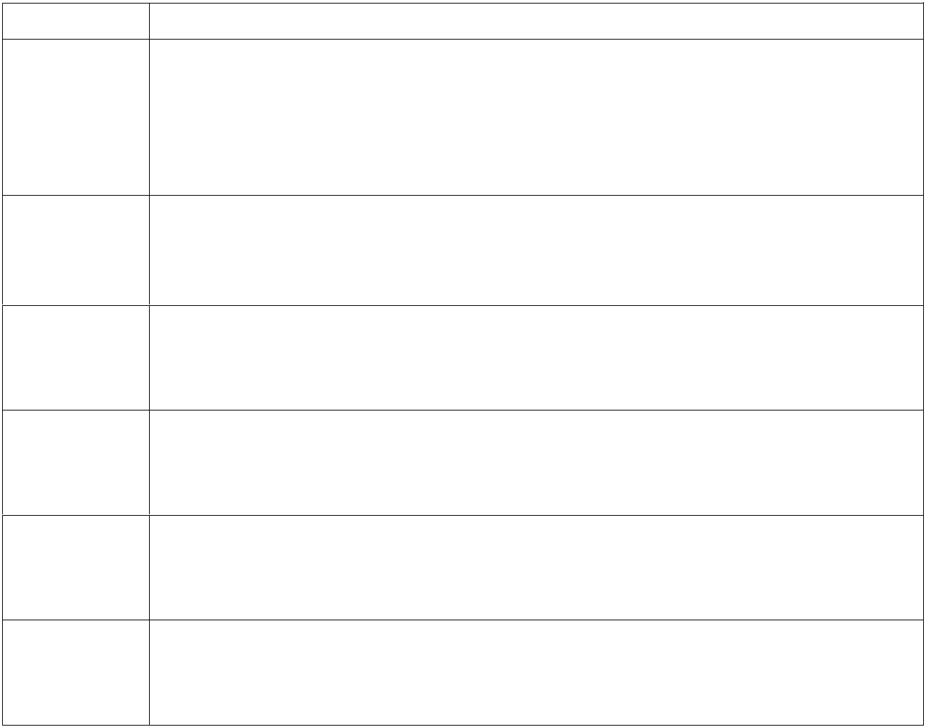

**Scope** **Description**

**singleton** **When bean scope is singleton then only one instance will be created for that bean and the same instance will be returned when you call getBean() method.**

**singleton is the default scope in the ApplicationContext container.**

**When scope is single-ton then default loading type is aggressive loading.**

**prototype** **When bean scope is prototype then every time a new instance will be created for that bean when you call getBean() method.**

**When scope is prototype then default loading type is lazy loading.**

**request** **Scopes a single bean definition to the lifecycle of a single HTTP request.**

**Single Bean instance will be created per HTTP Request**

**Only valid in the context of a web-aware Spring ApplicationContext.**

**session** **Scopes a single bean definition to the lifecycle of an HTTP Session.**

**Single Bean instance will be created per HTTP Session**

**Only valid in the context of a web-aware Spring ApplicationContext.**

**application** **Scopes a single bean definition to the lifecycle of a ServletContext.**

**Single Bean instance will be created per ServletContext.**

**Only valid in the context of a web-aware Spring ApplicationContext.**

**websocket** **Scopes a single bean definition to the lifecycle of a WebSocket.**

**Single Bean instance will be created per WebSocket.**

**Only valid in the context of a web-aware Spring ApplicationContext.**

**Usage:**

**@Scope(value="singleton")**

**@Scope(value=" prototype ")**

**@Scope("singleton")**

**@Scope("prototype")**



**www.coursecube.com** **8** **Spring-5 Study Guide**



**Bean Scope Example with Java Configuration**



**Lab2: Files required**



|  |  |  |  |  |
| --- | --- | --- | --- | --- |
| **1.** | **Lab2.java** | **2.** | | **Hello.java** |
|  |  |  |  |  |
| **3.** | **Hai.java** | **4.** | | **JLCAppConfig.java** |
|  |  |  |  |  |



**1. Lab2.java**

**package com.coursecube.spring;**

**import org.springframework.context.ApplicationContext;**

**import org.springframework.context.annotation.AnnotationConfigApplicationContext; /\***

* **@Author : Srinivas Dande**
* **@Company : CourseCube**
* **@Website : www.coursecube.com**
* **\*/**

**public class Lab2 {**

**public static void main(String[] args) {**

**ApplicationContext ctx=new AnnotationConfigApplicationContext(JLCAppConfig.class); System.out.println("---------Now Spring Container is Ready-----");**

**Hello hello1=(Hello)ctx.getBean("hello");**

**Hello hello2=(Hello)ctx.getBean("hello");**

**System.out.println(hello1==hello2);**

**Hai hai1=(Hai)ctx.getBean("hai");**

**Hai hai2=(Hai)ctx.getBean("hai");**

**System.out.println(hai1==hai2);**

**Hello hello=(Hello)ctx.getBean("hello");**

**hello.showHello();**

**Hai hai=(Hai)ctx.getBean("hai");**

**hai.showHai();**

**}**

**}**



**2. Hello.java**

**package com.coursecube.spring;**

**/\***

* **@Author : Srinivas Dande**
* **@Company : CourseCube**
* **@Website : www.coursecube.com**
* **\*/**

**public class Hello {**

**static {**



**www.coursecube.com** **9** **Spring-5 Study Guide**

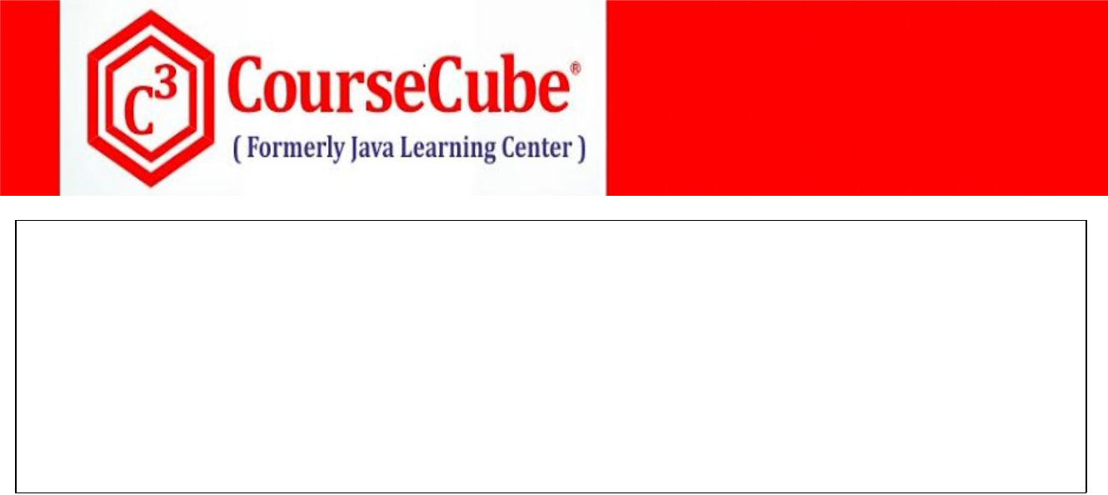

**System.out.println("Hello - S.B");**

**}**

**public Hello() {**

**System.out.println("Hello - D.C");**

**}**

**public void showHello() {**

**System.out.println("Hello-showHello()");**

**}**

**}**



**3. Hai.java**

**package com.coursecube.spring;**

**/\***

* **@Author : Srinivas Dande**
* **@Company : CourseCube**
* **@Website : www.coursecube.com**
* **\*/**

**public class Hai {**

**static {**

**System.out.println("Hai - S.B");**

**}**

**public Hai() {**

**System.out.println("Hai - D.C");**

**}**

**public void showHai() {**

**System.out.println("Hai-showHai()");**

**}**

**}**



1. **JLCAppConfig.java package com.coursecube.spring;**

**import org.springframework.context.annotation.Bean;**

**import org.springframework.context.annotation.Configuration; import org.springframework.context.annotation.Scope; /\***

* **@Author : Srinivas Dande**
* **@Company : CourseCube**
* **@Website : www.coursecube.com**
* **\*/**

**@Configuration**

**public class JLCAppConfig {**

**@Bean("hello")**

**@Scope("singleton")**

**public Hello createHello() {**

**System.out.println("-------createHello() ------ called");**



**www.coursecube.com** **10** **Spring-5 Study Guide**

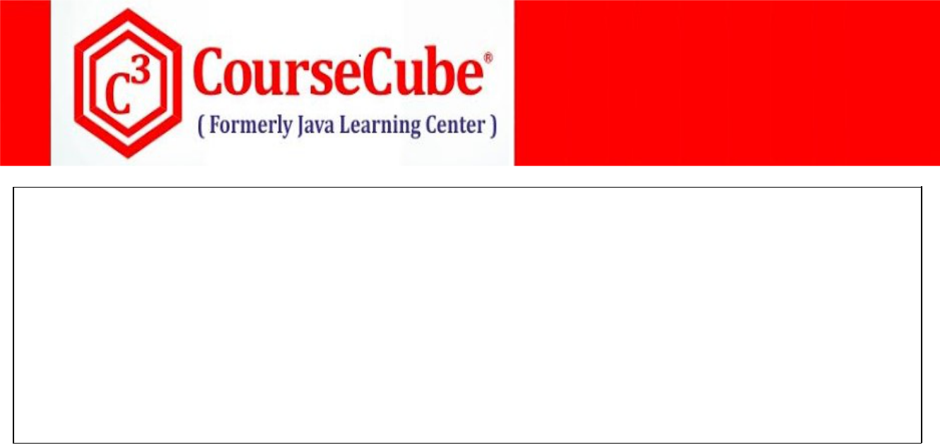

**return new Hello();**

**}**

**@Bean("hai")**

**@Scope("prototype")**

**public Hai createHai() {**

**System.out.println("-------createHai() ------ called");**

**return new Hai();**

**}**

**}**



**Bean Loading Types**

**Bean configured in the Spring Configuration Class can be loaded in two ways.**

* 1. **Aggressive loading or Eager loading**
  2. **Lazy loading.**

**Usage:**

**@Lazy(value="true")**

**@Lazy(value="true")**

**@Lazy("true")**

**@Lazy("false")**

1. **Aggressive loading or Eager loading**

**In the case of aggressive loading, all the Beans will be loaded, instantiated and initialized by the container at the container start-up.**



**Ex:**

**@Bean**

**@Lazy(false)**

**public Hello hello() {**

**return new Hello();**

**}**

1. **Lazy loading.**

**In the case of lazy loading, all the Beans will be loaded, instantiated and initialized when you or container try to use them by calling getBean() method.**



**Ex:**

**@Bean**

**@Lazy(true)**

**public Hello hello() {**

**return new Hello();**

**}**



**www.coursecube.com** **11** **Spring-5 Study Guide**



**Bean Loading Types Example with Java Configuration:**



**Lab3: Files required**



|  |  |  |
| --- | --- | --- |
| **1.** | **Lab3.java** | **New One** |
|  |  |  |
| **2.** | **Hello.java** | **Same as Lab2** |
|  |  |  |
| **3.** | **Hai.java** | **Same as Lab2** |
|  |  |  |
| **4.** | **JLCAppConfig.java** | **New One** |
|  |  |  |



**1. Lab3.java**

**package com.coursecube.spring;**

**import org.springframework.context.ApplicationContext;**

**import org.springframework.context.annotation.AnnotationConfigApplicationContext; /\***

* **@Author : Srinivas Dande**
* **@Company : CourseCube**
* **@Website : www.coursecube.com**
* **\*/**

**public class Lab3 {**

**public static void main(String[] args) {**

**ApplicationContext ctx=new AnnotationConfigApplicationContext(JLCAppConfig.class); System.out.println("---------Now Spring Container is Ready-----");**

**Hello hello=(Hello)ctx.getBean("hello");**

**hello.showHello();**

**Hai hai=(Hai)ctx.getBean("hai");**

**hai.showHai();**

**}**

**}**



1. **JLCAppConfig.java package com.coursecube.spring;**

**import org.springframework.context.annotation.Bean;**

**import org.springframework.context.annotation.Configuration; import org.springframework.context.annotation.Lazy; import org.springframework.context.annotation.Scope; /\***

* **@Author : Srinivas Dande**
* **@Company : CourseCube**
* **@Website : www.coursecube.com**
* **\*/**



**www.coursecube.com** **12** **Spring-5 Study Guide**



**@Configuration**

**public class JLCAppConfig {**

**@Bean("hello")**

**@Scope("singleton")**

**@Lazy(true)**

**public Hello createHello() {**

**System.out.println("-------createHello() ------ called");**

**return new Hello();**

**}**

**@Bean("hai")**

**@Scope("prototype")**

**@Lazy(true)**

**public Hai createHai() {**

**System.out.println("-------createHai() ------ called");**

**return new Hai();**

**}**

**}**



**www.coursecube.com** **13** **Spring-5 Study Guide**



**Using Existing Singletons**

**Lab4: Files required**



**5. Lab4.java** **6. Hello.java**

**7. JLCAppConfig.java**



**1. Lab4.java**

**package com.coursecube.spring;**

**import org.springframework.context.ApplicationContext;**

**import org.springframework.context.annotation.AnnotationConfigApplicationContext; /\***

* **@Author : Srinivas Dande**
* **@Company : CourseCube**
* **@Website : www.coursecube.com**
* **\*/**

**public class Lab4 {**

**public static void main(String[] args) {**

**ApplicationContext ctx=new AnnotationConfigApplicationContext(JLCAppConfig.class); System.out.println("---------Now Spring Container is Ready-----");**

**Hello hello=(Hello)ctx.getBean("myhello");**

**hello.show();**

**Runtime rt =(Runtime)ctx.getBean("myruntime"); System.out.println(rt.availableProcessors()); } }**



**2. Hello.java**

**package com.coursecube.spring;**

**/\***

* **@Author : Srinivas Dande**
* **@Company : CourseCube**
* **@Website : www.coursecube.com**
* **\*/**

**public class Hello {**

**static Hello hello;**

**static {**

**hello=new Hello();**

**}**

**private Hello() {**

**}**

**public static Hello getHello() {**

**return hello;**

**}**

**public void show() {**

**System.out.println("Hello-show()");**

**} }**



**www.coursecube.com** **14** **Spring-5 Study Guide**

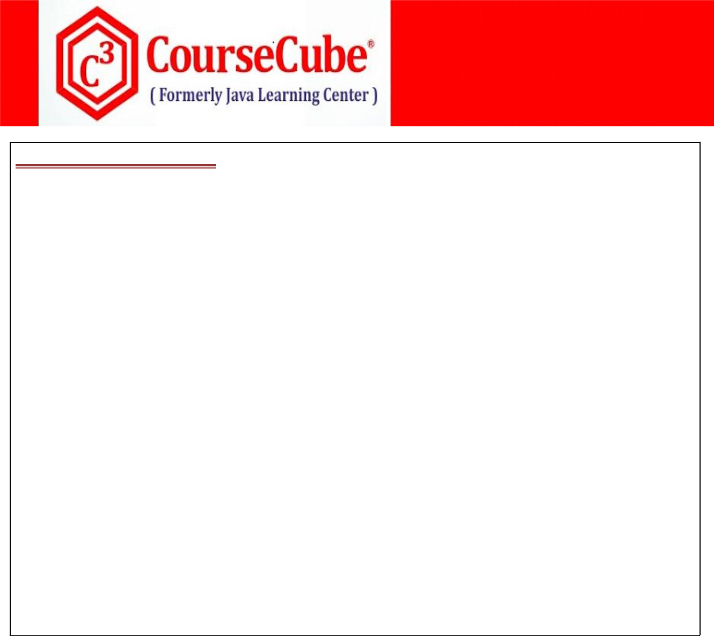

1. **JLCAppConfig.java package com.coursecube.spring;**

**import org.springframework.context.annotation.Bean;**

**import org.springframework.context.annotation.Configuration; /\***

* **@Author : Srinivas Dande**
* **@Company : CourseCube**
* **@Website : www.coursecube.com**
* **\*/**

**@Configuration**

**public class JLCAppConfig {**

**@Bean("myhello")**

**public Hello createHello() {**

**System.out.println("-------createHello() ------ called");**

**Hello hello=Hello.getHello();**

**return hello;**

**}**

**@Bean("myruntime")**

**public Runtime createRT() {**

**System.out.println("-------createRT() ------ called");**

**Runtime rt=Runtime.getRuntime();**

**return rt;**

**}**

**}**



**Writing Multiple Configuration classes**

**JLCAppConfig - Spring Configuration class which contains all the Bean Definitions.**

**You can write Multiple Configuration classes in One Spring Application.**

**There are 3 ways to Handle Multiple Configuration classes**

* 1. **Using the constructor of AnnotationConfigApplicationContext**
  2. **Using @Import annotaion**
  3. **Using @ImportResource annotation**

1. **Using the constructor of AnnotationConfigApplicationContext (Refer Lab5)**

**Specify the Multiple Configuration classes as Parameters for Constructor of AnnotationConfigApplicationContext**

**ApplicationContext ctx= new AnnotationConfigApplicationContext ( JLCAppConfig1.class, JLCAppConfig2.class, JLCAppConfig3.class);**



**www.coursecube.com** **15** **Spring-5 Study Guide**



1. **Using @Import annotation (Refer Lab6 )**

**Specify the One Configuration class as Parameters for Constructor of AnnotationConfigApplicationContext**

**ApplicationContext ctx=new AnnotationConfigApplicationContext (JLCAppConfig1.class);**

**Import Remaining Configuration classes using @Import Annotation**

**@Import({JLCAppConfig1.class,JLCAppConfig3.class})**

**public class JLCAppConfig2{**

**}...**

1. **Using @ImportResource annotation (Refer Lab7)**

**This is Required only when some of your beans are configured in XML file. Consider the Bean Configurations as follows.**

**jlc1.xml - Configure A bean here**

**jlc2.xml - Configure B bean here**

**JLCAppConfig -- Hello,Hai**

**Note : place jlc1.xml and jlc2.xml in src folder.**

**Specify the One Configuration class as Parameters for Constructor of AnnotationConfigApplicationContext**

**ApplicationContext ctx=new AnnotationConfigApplicationContext(JLCAppConfig.class);**

**Import Remaining Configuration XML files using @ ImportResource Annotation**

**@ImportResource({"jlc1.xml","jlc2.xml"})**

**public class JLCAppConfig {**

**}**

**Lab5: Files required**



|  |  |  |  |
| --- | --- | --- | --- |
| **1.** | **Lab5.java** | **2.** | **A.java** |
|  |  |  |  |
| **3.** | **B.java** | **4.** | **Hai.java** |
|  |  |  |  |
| **5.** | **Hello.java** | **6.** | **JLCAppConfig1.java** |
|  |  |  |  |
| **7.** | **JLCAppConfig2.java** | **8.** | **JLCAppConfig3.java** |
|  |  |  |  |



**1. Lab5.java**

**package com.coursecube.spring;**

**import org.springframework.context.ApplicationContext;**

**import org.springframework.context.annotation.AnnotationConfigApplicationContext;**



**www.coursecube.com** **16** **Spring-5 Study Guide**



**/\***

* **@Author : Srinivas Dande**
* **@Company : CourseCube**
* **@Website : www.coursecube.com**
* **\*/**

**public class Lab5 {**

**public static void main(String[] args) {**

**ApplicationContext ctx=new**

**AnnotationConfigApplicationContext(JLCAppConfig1.class,JLCAppConfig2.class,JLCAppConfig3.class**

**);**

**System.out.println("---------Now Spring Container is Ready-----");**

**Hello hello=(Hello)ctx.getBean("myhello");**

**hello.show();**

**Hai hai=(Hai) ctx.getBean("myhai");**

**hai.show();**

**}**

**}**



**2. A.java**

**package com.coursecube.spring;**

**/\***

* **@Author : Srinivas Dande**
* **@Company : CourseCube**
* **@Website : www.coursecube.com**
* **\*/**

**public class A {**

**int a; //S.I**

**String msg; //S.I**

**static {**

**System.out.println("A - S.B");**

**}**

**public A() {**

**System.out.println("A - D.C");**

**}**

**public void setA(int a) {**

**System.out.println("A - setA()");**

**this.a = a;**

**}**

**public void setMsg(String msg) {**

**System.out.println("A - setMsg()");**

**this.msg = msg;**

**}**

**public String toString() {**

**return ""+a +"\t"+msg;**

**}**

**}**



**www.coursecube.com** **17** **Spring-5 Study Guide**

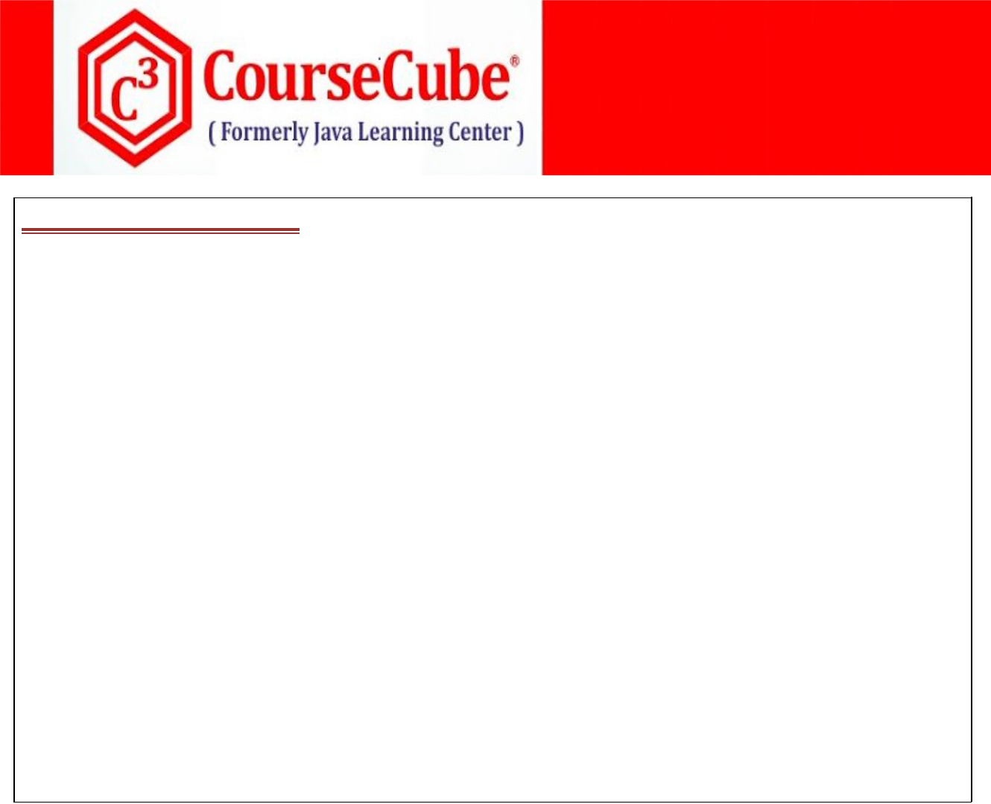

**3. B.java**

**package com.coursecube.spring;**

**/\***

* **@Author : Srinivas Dande**
* **@Company : CourseCube**
* **@Website : www.coursecube.com**
* **\*/**

**public class B {**

**int b; //C.I**

**String str; //C.I**

**static {**

**System.out.println("B - S.B");**

**}**

**public B(int b, String str) {**

**System.out.println("B - 2 arg");**

**this.b = b;**

**this.str = str;**

**}**

**public String toString() {**

**return ""+b+"\t"+str;**

**}**

**}**



**4. Hai.java**

**package com.coursecube.spring;**

**/\***

* **@Author : Srinivas Dande**
* **@Company : CourseCube**
* **@Website : www.coursecube.com**
* **\*/**

**public class Hai {**

**A aobj; //S.I**

**B bobj; //S.I**

**static {**

**System.out.println("Hai - S.B");**

**}**

**public Hai() {**

**System.out.println("Hai() - D.C");**

**}**

**public void setAobj(A aobj) {**

**System.out.println("Hai- setAobj() ");**

**this.aobj = aobj;**

**}**

**public void setBobj(B bobj) {**

**System.out.println("Hai- setBobj() ");**

**this.bobj = bobj;**

**}**



**www.coursecube.com** **18** **Spring-5 Study Guide**

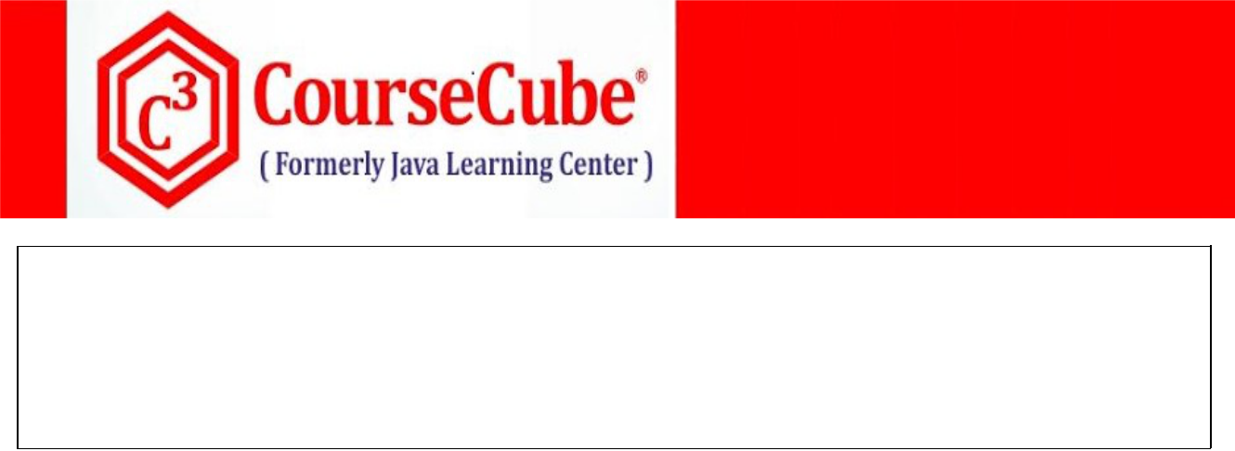

**public void show() {**

**System.out.println("Hai- show()");**

**System.out.println(aobj);**

**System.out.println(bobj);**

**}**

**}**



**5. Hello.java**

**package com.coursecube.spring;**

**/\***

* **@Author : Srinivas Dande**
* **@Company : CourseCube**
* **@Website : www.coursecube.com**
* **\*/**

**public class Hello {**

**A aobj; //C.I**

**B bobj; //C.I**

**static {**

**System.out.println("Hello - S.B");**

**}**

**public Hello() {**

**System.out.println("Hello() - D.C");**

**}**

**public Hello(A aobj,B bobj) {**

**System.out.println("Hello(A,B) - 2arg");**

**this.aobj=aobj;**

**this.bobj = bobj;**

**}**

**public void show() {**

**System.out.println("Hello-show()");**

**System.out.println(aobj);**

**System.out.println(bobj);**

**}**

**}**



1. **JLCAppConfig1.java package com.coursecube.spring;**

**import org.springframework.context.annotation.Bean;**

**import org.springframework.context.annotation.Configuration; /\***

* **@Author : Srinivas Dande**
* **@Company : CourseCube**
* **@Website : www.coursecube.com**
* **\*/**

**@Configuration**

**public class JLCAppConfig1 {**



**www.coursecube.com** **19** **Spring-5 Study Guide**



**@Bean("ao")**

**public A createA() {**

**A ao=new A();**

**ao.setA(101);**

**ao.setMsg("I am A");**

**return ao;**

**}**

**@Bean("bo")**

**public B createB() {**

**B bo=new B(102,"I am B");**

**return bo;**

**}**

**}**



1. **JLCAppConfig2.java package com.coursecube.spring;**

**import org.springframework.context.annotation.Bean;**

**import org.springframework.context.annotation.Configuration; /\***

* **@Author : Srinivas Dande**
* **@Company : CourseCube**
* **@Website : www.coursecube.com**
* **\*/**

**@Configuration**

**public class JLCAppConfig2 {**

**@Bean("myhello")**

**public Hello createHello(A ao,B bo) {**

**Hello h=new Hello(ao,bo);**

**return h;**

**}**

**}**



1. **JLCAppConfig3.java package com.coursecube.spring;**

**import org.springframework.context.annotation.Bean;**

**import org.springframework.context.annotation.Configuration; /\***

* **@Author : Srinivas Dande**
* **@Company : CourseCube**
* **@Website : www.coursecube.com**
* **\*/**

**@Configuration**

**public class JLCAppConfig3 {**



**www.coursecube.com** **20** **Spring-5 Study Guide**



**@Bean("myhai")**

**public Hai createHai(A ao,B bo) {**

**Hai hai=new Hai();**

**hai.setAobj(ao);**

**hai.setBobj(bo);**

**return hai;**

**}**

**}**

**Lab6: Files required**



|  |  |  |
| --- | --- | --- |
| **1.** | **Lab6.java** | **New One** |
|  |  |  |
| **2.** | **A.java** | **Same as Lab5** |
|  |  |  |
| **3.** | **B.java** | **Same as Lab5** |
|  |  |  |
| **4.** | **Hai.java** | **Same as Lab5** |
|  |  |  |
| **5.** | **Hello.java** | **Same as Lab5** |
|  |  |  |
| **6.** | **JLCAppConfig1.java** | **New One** |
|  |  |  |
| **7.** | **JLCAppConfig2.java** | **Same as Lab5** |
|  |  |  |
| **8.** | **JLCAppConfig3.java** | **Same as Lab5** |
|  |  |  |



**1. Lab6.java**

**package com.coursecube.spring;**

**import org.springframework.context.ApplicationContext;**

**import org.springframework.context.annotation.AnnotationConfigApplicationContext; /\***

* **@Author : Srinivas Dande**
* **@Company : CourseCube**
* **@Website : www.coursecube.com**
* **\*/**

**public class Lab6 {**

**public static void main(String[] args) {**

**ApplicationContext ctx=new AnnotationConfigApplicationContext(JLCAppConfig1.class); System.out.println("---------Now Spring Container is Ready-----");**

**Hello hello=(Hello)ctx.getBean("myhello");**

**hello.show();**

**Hai hai=(Hai) ctx.getBean("myhai");**

**hai.show();**

**}**

**}**



**www.coursecube.com** **21** **Spring-5 Study Guide**

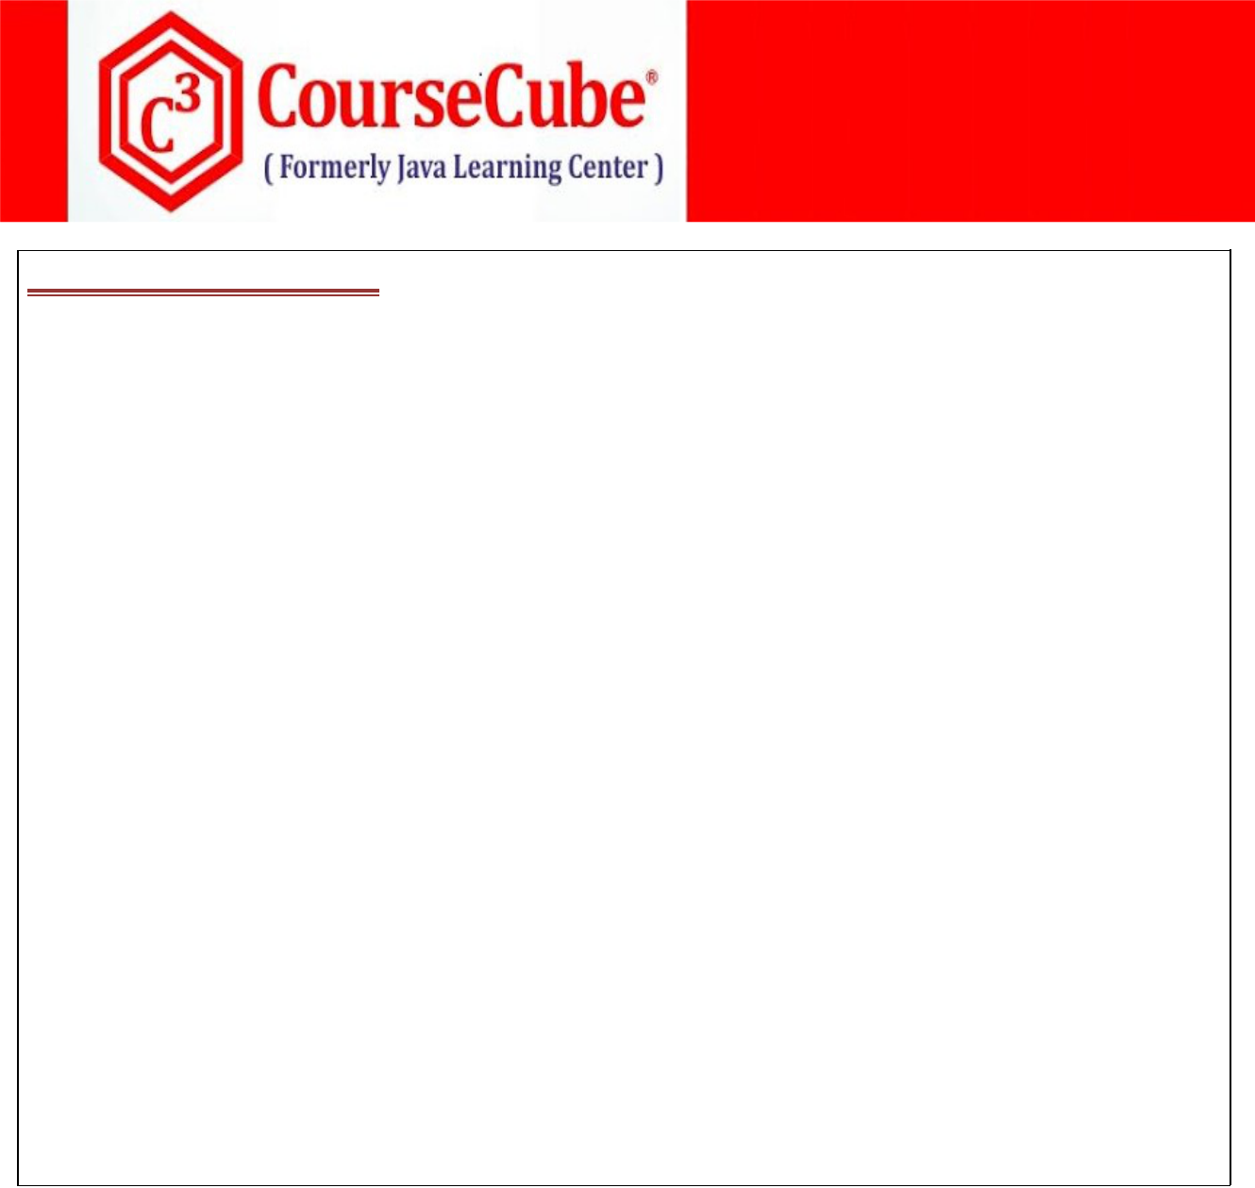

1. **JLCAppConfig1.java package com.coursecube.spring;**

**import org.springframework.context.annotation.Bean;**

**import org.springframework.context.annotation.Configuration; /\***

* **@Author : Srinivas Dande**
* **@Company : CourseCube**
* **@Website : www.coursecube.com**
* **\*/**

**@Configuration**

**@Import({JLCAppConfig2.class,JLCAppConfig3.class})**

**public class JLCAppConfig1 {**

**@Bean("ao")**

**public A createA() {**

**A ao=new A();**

**ao.setA(101);**

**ao.setMsg("I am A");**

**return ao;**

**}**

**@Bean("bo")**

**public B createB() {**

**B bo=new B(102,"I am B");**

**return bo;**

**}**

**}**

**Lab7: Files required**



|  |  |  |
| --- | --- | --- |
| **1.** | **Lab7.java** | **New One** |
|  |  |  |
| **2.** | **A.java** | **Same as Lab5** |
|  |  |  |
| **3.** | **B.java** | **Same as Lab5** |
|  |  |  |
| **4.** | **Hai.java** | **Same as Lab5** |
|  |  |  |
| **5.** | **Hello.java** | **Same as Lab5** |
|  |  |  |
| **6.** | **JLCAppConfig.java** | **New One** |
|  |  |  |
| **7.** | **jlc1.xml** | **New One** |
|  |  |  |
| **8.** | **jlc2.xml** | **New One** |
|  |  |  |



**1. Lab7.java**

**package com.coursecube.spring;**

**import org.springframework.context.ApplicationContext;**

**import org.springframework.context.annotation.AnnotationConfigApplicationContext; /\***

* **@Author : Srinivas Dande**
* **@Company : CourseCube**



**www.coursecube.com** **22** **Spring-5 Study Guide**

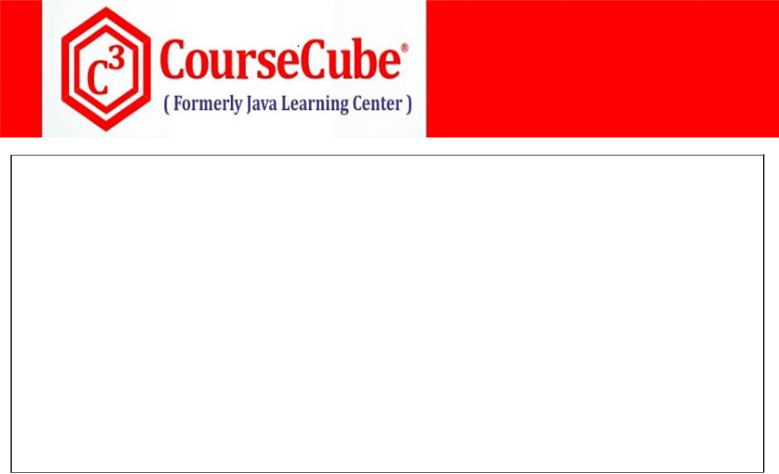

* **@Website : www.coursecube.com**
* **\*/**

**public class Lab7 {**

**public static void main(String[] args) {**

**ApplicationContext ctx=new AnnotationConfigApplicationContext(JLCAppConfig.class); System.out.println("---------Now Spring Container is Ready-----");**

**Hello hello=(Hello)ctx.getBean("myhello");**

**hello.show();**

**Hai hai=(Hai) ctx.getBean("myhai");**

**hai.show();**

**}**

**}**



1. **JLCAppConfig.java package com.coursecube.spring;**

**import org.springframework.context.annotation.Bean;**

**import org.springframework.context.annotation.Configuration; import org.springframework.context.annotation.ImportResource; /\***

* **@Author : Srinivas Dande**
* **@Company : CourseCube**
* **@Website : www.coursecube.com**
* **\*/**

**@Configuration**

**@ImportResource({"jlc1.xml","jlc2.xml"})**

**public class JLCAppConfig {**

**@Bean("myhello")**

**public Hello createHello(A ao,B bo) {**

**Hello h=new Hello(ao,bo);**

**return h;**

**}**

**@Bean("myhai")**

**public Hai createHai(A ao,B bo) {**

**Hai hai=new Hai();**

**hai.setAobj(ao);**

**hai.setBobj(bo);**

**return hai;**

**}**

**}**



**www.coursecube.com** **23** **Spring-5 Study Guide**



**7. jlc1.xml**

**<?xml version="1.0" encoding="UTF-8"?>**

**<beans xmlns="http://www.springframework.org/schema/beans" xmlns:xsi="http://www.w3.org/2001/XMLSchema-instance" xsi:schemaLocation="http://www.springframework.org/schema/beans**

**http://www.springframework.org/schema/beans/spring-beans.xsd">**

**<bean id="aobj" class="com.coursecube.spring.A"> <property name="a" value="99"/> <property name="msg" value="I am A"/>**

**</bean>**

**</beans>**



**8. jlc2.xml**

**<?xml version="1.0" encoding="UTF-8"?>**

**<beans xmlns="http://www.springframework.org/schema/beans" xmlns:xsi="http://www.w3.org/2001/XMLSchema-instance" xsi:schemaLocation="http://www.springframework.org/schema/beans**

**http://www.springframework.org/schema/beans/spring-beans.xsd">**

**<bean id="bobj" class="com.coursecube.spring.B"> <constructor-arg value="88"/> <constructor-arg value="I am B"/> </bean>**

**</beans>**



**Injecting Various Types of Bean Properties:**

**You can Inject the following types of Bean Properties.**

1. **Simple Types(Primitives,Wrappers,Strings,Dates).**
2. **List type**
3. **Set type**
4. **Map type**
5. **java.util.Properties type**
6. **other Beans**
7. **Collection of Other Beans**

**All of these types of Bean Properties can be Injected with Setter Injection or Constrcutor Injection.**

**Lab8: Injecting Various Types of Properties**

**Lab9: Injecting Two List Types**



**www.coursecube.com** **24** **Spring-5 Study Guide**



**Lab8: Files required**

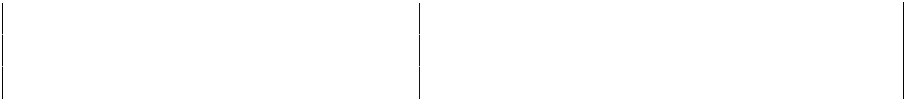

|  |  |  |  |
| --- | --- | --- | --- |
| **1.** | **Lab8.java** | **2.** | **Address.java** |
|  |  |  |  |
| **3.** | **Account.java** | **4.** | **Customer.java** |
|  |  |  |  |
| **5.** | **JLCAppConfig.java** |  |  |
|  |  |  |  |



**1. Lab8.java**

**package com.coursecube.spring;**

**import org.springframework.context.ApplicationContext;**

**import org.springframework.context.annotation.AnnotationConfigApplicationContext; /\***

* **@Author : Srinivas Dande**
* **@Company : CourseCube**
* **@Website : www.coursecube.com**
* **\*/**

**public class Lab8 {**

**public static void main(String[] args) {**

**ApplicationContext ctx=new AnnotationConfigApplicationContext(JLCAppConfig.class); System.out.println("---------Now Spring Container is Ready-----");**

**Customer cust=(Customer) ctx.getBean("mycust");**

**System.out.println(cust);**

**System.out.println(cust.getEmails());**

**System.out.println(cust.getPhones());**

**System.out.println(cust.getRefs());**

**System.out.println(cust.getAddress());**

**for(Account acc:cust.getAccounts()) {**

**System.out.println(acc);**

**}**

**}**

**}**



**2. Address.java**

**package com.coursecube.spring;**

**/\***

* **@Author : Srinivas Dande**
* **@Company : CourseCube**
* **@Website : www.coursecube.com**
* **\*/**

**public class Address {**

**private String street;**

**private String city;**

**private String state;**

**public Address() {}**



**www.coursecube.com** **25** **Spring-5 Study Guide**



**public void setStreet(String street) {**

**this.street = street;**

**}**

**public void setCity(String city) {**

**this.city = city;**

**}**

**public void setState(String state) {**

**this.state = state;**

**}**

**@Override**

**public String toString() {**

**return street + ", " + city + ", " + state ;**

**}**

**}**



**3. Account.java**

**package com.coursecube.spring;**

**/\***

* **@Author : Srinivas Dande**
* **@Company : CourseCube**
* **@Website : www.coursecube.com**
* **\*/**

**public class Account {**

**private int accno;**

**private String atype;**

**private double bal;**

**public Account() {}**

**public Account(int accno, String atype, double bal) { super();**

**this.accno = accno;**

**this.atype = atype;**

**this.bal = bal;**

**}**

**@Override**

**public String toString() {**

**return accno + ", " + atype + ", " + bal ;**

**}**

**}**



**4. Customer.java**

**package com.coursecube.spring;**

**import java.util.*;**

**/\***

* **@Author : Srinivas Dande**
* **@Company : CourseCube**
* **@Website : www.coursecube.com**
* **\*/**



**www.coursecube.com** **26** **Spring-5 Study Guide**

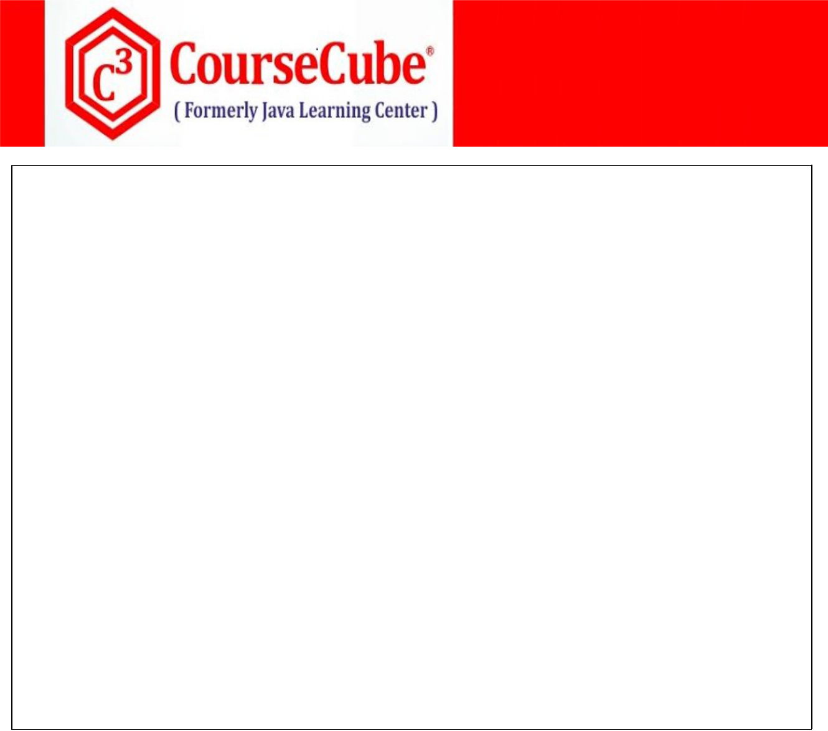

**public class Customer {**

**private int cid;//1**

**private String cname;//1**

**private String email;//1**

**private long phone;//1**

**private List<String> emails;//2**

**private Set<Integer> phones;//3**

**private Map<String,Integer> refs;//4**

**private Properties myprops;//5**

**private Address address;//6**

**private List<Account> accounts;//7**

**public Customer() {}**

**public Customer(int cid, String cname, String email, long phone) { super();**

**this.cid = cid;**

**this.cname = cname;**

**this.email = email;**

**this.phone = phone;**

**}**

**//Setters and Getters**

**@Override**

**public String toString() {**

**return cid + ", " + cname + ", " + email + ", " + phone;**

**}**

**}**



1. **JLCAppConfig.java package com.coursecube.spring;**

**import java.util.*;**

**import org.springframework.context.annotation.Bean;**

**import org.springframework.context.annotation.Configuration; /\***

* **@Author : Srinivas Dande**
* **@Company : CourseCube**
* **@Website : www.coursecube.com**
* **\*/**

**@Configuration**

**public class JLCAppConfig {**

**@Bean(name="myemails")**

**public List<String> getEmails(){**

**System.out.println("JLCAppConfig -getEmails() ");**

**List<String> ems=new ArrayList<>();**

**ems.add("sri@jlc");**

**ems.add("vas@jlc");**

**ems.add("sd@jlc");**

**return ems;**

**}**



**www.coursecube.com** **27** **Spring-5 Study Guide**



**@Bean(name="myphones")**

**public Set<Integer> getPhones(){**

**System.out.println("JLCAppConfig -getPhones() ");**

**Set<Integer> phs=new TreeSet<>();**

**phs.add(111);**

**phs.add(222);**

**phs.add(333);**

**return phs;**

**}**

**@Bean(name="myrefs")**

**public Map<String,Integer> getRefs(){ System.out.println("JLCAppConfig -getRefs() "); Map<String,Integer> refs=new TreeMap<>(); refs.put("A",11);**

**refs.put("B",22);**

**refs.put("C",33);**

**refs.put("D",44);**

**return refs;**

**}**

**@Bean(name="myprops")**

**public Properties getProps(){**

**System.out.println("JLCAppConfig -getProps() ");**

**Properties props=new Properties();**

**props.put("A",11);**

**props.put("B",22);**

**props.put("C",33);**

**props.put("D",44);**

**return props;**

**}**

**@Bean(name="myadd")**

**public Address getAdd() {**

**System.out.println("JLCAppConfig -getAdd() ");**

**Address add=new Address();**

**add.setStreet("BTM Layout");**

**add.setCity("Bangalore");**

**add.setState("KA");**

**return add;**

**}**

**@Bean(name="myaccs")**

**public List<Account> getAccounts(){ System.out.println("JLCAppConfig -getAccounts() ");**

**List<Account> myaccs=new ArrayList<>();**

**myaccs.add(new Account(101,"SA",15000));**



**www.coursecube.com** **28** **Spring-5 Study Guide**

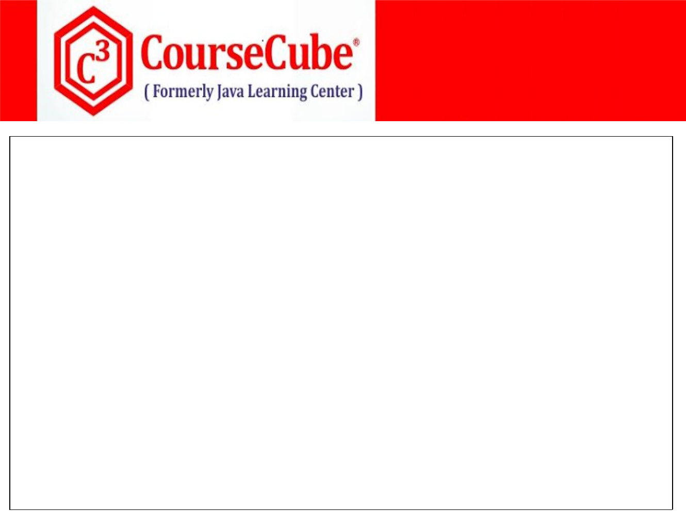

**myaccs.add(new Account(102,"CA",25000));**

**myaccs.add(new Account(103,"DA",35000));**

**return myaccs;**

**}**

**@Bean(name="mycust")**

**public Customer createCustomer(List<String> myemails,Set<Integer> myphones, Map<String,Integer> myrefs,Properties myprops,Address myadd, List<Account> myaccs) {**

**System.out.println("JLCAppConfig -createCustomer() ");**

**Customer cust=new Customer(101,"Srinivas","Sri@jlc.com",12345);**

**cust.setEmails(myemails);**

**cust.setPhones(myphones);**

**cust.setRefs(myrefs);**

**cust.setMyprops(myprops);**

**cust.setAddress(myadd);**

**cust.setAccounts(myaccs);**

**return cust;**

**}**

**}**

**Lab9: Files required**



**1. Lab9.java** **2. Customer.java**

**3. JLCAppConfig.java**



**1. Lab9.java**

**package com.coursecube.spring;**

**import org.springframework.context.ApplicationContext;**

**import org.springframework.context.annotation.AnnotationConfigApplicationContext; /\***

* **@Author : Srinivas Dande**
* **@Company : CourseCube**
* **@Website : www.coursecube.com**
* **\*/**

**public class Lab9 {**

**public static void main(String[] args) {**

**ApplicationContext ctx=new AnnotationConfigApplicationContext(JLCAppConfig.class); System.out.println("---------Now Spring Container is Ready-----");**

**Customer cust=(Customer) ctx.getBean("mycust");**

**System.out.println(cust);**

**System.out.println(cust.getEmails());**

**System.out.println(cust.getPhones());**

**}**

**}**



**www.coursecube.com** **29** **Spring-5 Study Guide**



**2. Customer.java**

**package com.coursecube.spring;**

**import java.util.*;**

**/\***

* **@Author : Srinivas Dande**
* **@Company : CourseCube**
* **@Website : www.coursecube.com**
* **\*/**

**public class Customer {**

**private int cid;**

**private String cname;**

**private String email;**

**private long phone;**

**private List<String> emails;**

**private List<String> phones;**

**public Customer() {}**

**public Customer(int cid, String cname, String email, long phone, List<String> emails, List<String> phones) {**

**super();**

**this.cid = cid;**

**this.cname = cname;**

**this.email = email;**

**this.phone = phone;**

**this.emails = emails;**

**this.phones = phones;**

**}**

**//Setters and Getters**

**@Override**

**public String toString() {**

**return cid + ", " + cname + ", " + email + ", " + phone;**

**}**

**}**



1. **JLCAppConfig.java package com.coursecube.spring;**

**import java.util.*;**

**import org.springframework.context.annotation.Bean;**

**import org.springframework.context.annotation.Configuration; /\***

* **@Author : Srinivas Dande**
* **@Company : CourseCube**
* **@Website : www.coursecube.com**
* **\*/**

**@Configuration**

**public class JLCAppConfig {**



**www.coursecube.com** **30** **Spring-5 Study Guide**



**@Bean(name="myemails")**

**public List<String> getEmails(){**

**List<String> ems=new ArrayList<>();**

**ems.add("sri@jlc");**

**ems.add("vas@jlc");**

**ems.add("sd@jlc");**

**return ems;**

**}**

**@Bean(name="myphones")**

**public List<String> getPhones(){**

**List<String> phs=new ArrayList<>();**

**phs.add("111");**

**phs.add("222");**

**phs.add("333");**

**return phs;**

**}**

**@Bean(name="mycust")**

**public Customer createCustomer(List<String> myemails,List<String> myphones) {**

**Customer cust=new Customer(101,"Srinivas","Sri@jlc.com",12345,myemails,myphones);**

**return cust;**

**}**

**}**



**Wiring**

**Wiring is the Process of Inejecting Bean Dependecies.**

**Wiring Can be done in two ways.**

* 1. **Explicit Wiring**
  2. **Implicit Wiring (or) AutoWiring**

**1)Explicit Wiring:**

**In the case of Explicit Wiring, Bean Dependencies has to be specified by you explicitly.**

**Ex:**

**class Hello {**

**Hai hai;**

**….**

**}**

**@Bean("myhello")**

**public Hello createHello(Hai hai) {**

**Hello h=new Hello();**

**h.setHai(hai);**

**return h;**

**}**

**In the above Example, We are explicitly specifying the Hello dependecy called Hai**



**www.coursecube.com** **31** **Spring-5 Study Guide**



**Case 1: What happens when 0 Matching Beans found.(Refer Lab10)**

**Exception will be thrown**

**NoSuchBeanDefinitionException: No qualifying bean of type 'com.coursecube.spring.Hai' available: expected at least 1 bean**

**Note: In the case of Collections Only , Container creates the Empty Object and passes that as paramter .(Ref. Lab9)**

**Case 2: What happens when exactly 1 Matching bean found.(Refer Lab11)**

**Identified single bean will be injected with Setter method.**

**Case 3: What happens when two or more Matching beans found.**

**If Any bean name is matching with local variable name then that will be injected with setter method.(Refer Lab12)**

**If Any bean name is not matching with local variable name then Exception will be thrown.(Ref.Lab13)**

**NoUniqueBeanDefinitionException: No qualifying bean of type ……..expected single matching bean but found 2: myhai1,myhai2**

**Lab10: Files required**



|  |  |  |  |
| --- | --- | --- | --- |
| **1.** | **Lab10.java** | **2.** | **Hai.java** |
|  |  |  |  |
| **3.** | **Hello.java** | **4.** | **JLCAppConfig.java** |
|  |  |  |  |



**1. Lab10.java**

**package com.coursecube.spring;**

**import org.springframework.context.ApplicationContext;**

**import org.springframework.context.annotation.AnnotationConfigApplicationContext; /\***

* **@Author : Srinivas Dande**
* **@Company : CourseCube**
* **@Website : www.coursecube.com**
* **\*/**

**public class Lab10 {**

**public static void main(String[] args) {**

**ApplicationContext ctx=new AnnotationConfigApplicationContext(JLCAppConfig.class); System.out.println("---------Now Spring Container is Ready-----");**

**Hello hello=(Hello)ctx.getBean("myhello");**

**hello.show();**

**}**

**}**



**www.coursecube.com** **32** **Spring-5 Study Guide**

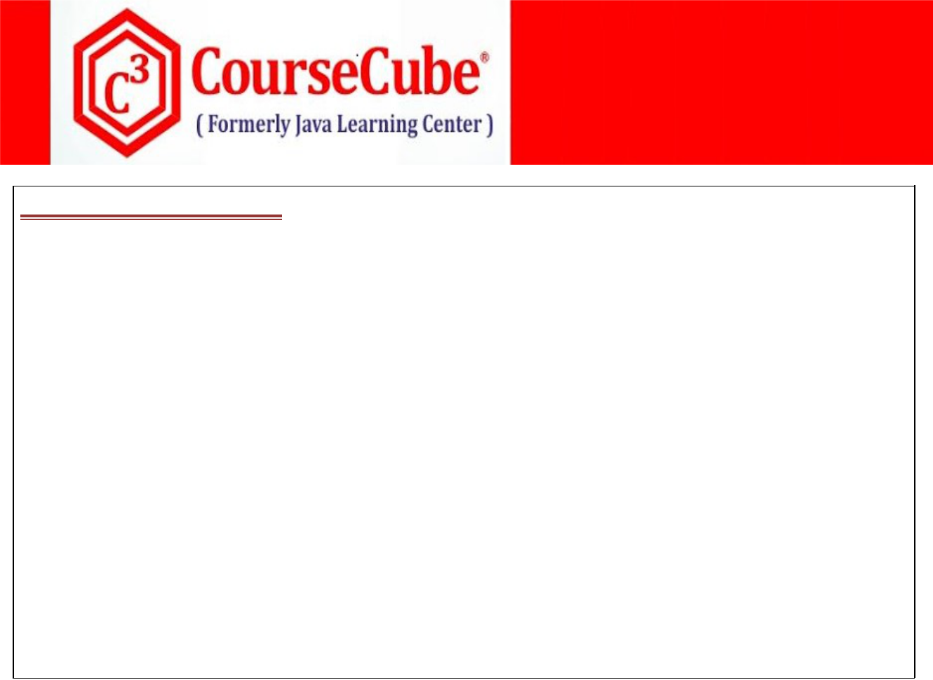

**2. Hai.java**

**package com.coursecube.spring;**

**/\***

* **@Author : Srinivas Dande**
* **@Company : CourseCube**
* **@Website : www.coursecube.com**
* **\*/**

**public class Hai {**

**static {**

**System.out.println("Hai - S.B");**

**}**

**public Hai() {**

**System.out.println("Hai() - D.C");**

**}**

**public String toString() {**

**return "Hai Guys, I am Hai Bean";**

**}**

**}**



**3. Hello.java**

**package com.coursecube.spring;**

**/\***

* **@Author : Srinivas Dande**
* **@Company : CourseCube**
* **@Website : www.coursecube.com**
* **\*/**

**public class Hello {**

**Hai hai; //1. Dependency**

**static {**

**System.out.println("Hello - S.B");**

**}**

**public Hello() {**

**System.out.println("Hello() - D.C");**

**}**

**public void setHai(Hai hai) { //2. Setter Injection System.out.println("Hello - setHai()"); this.hai = hai;**

**}**

**public void show() {**

**System.out.println("Hello-show()");**

**System.out.println(hai);**

**}**

**}**



**www.coursecube.com** **33** **Spring-5 Study Guide**

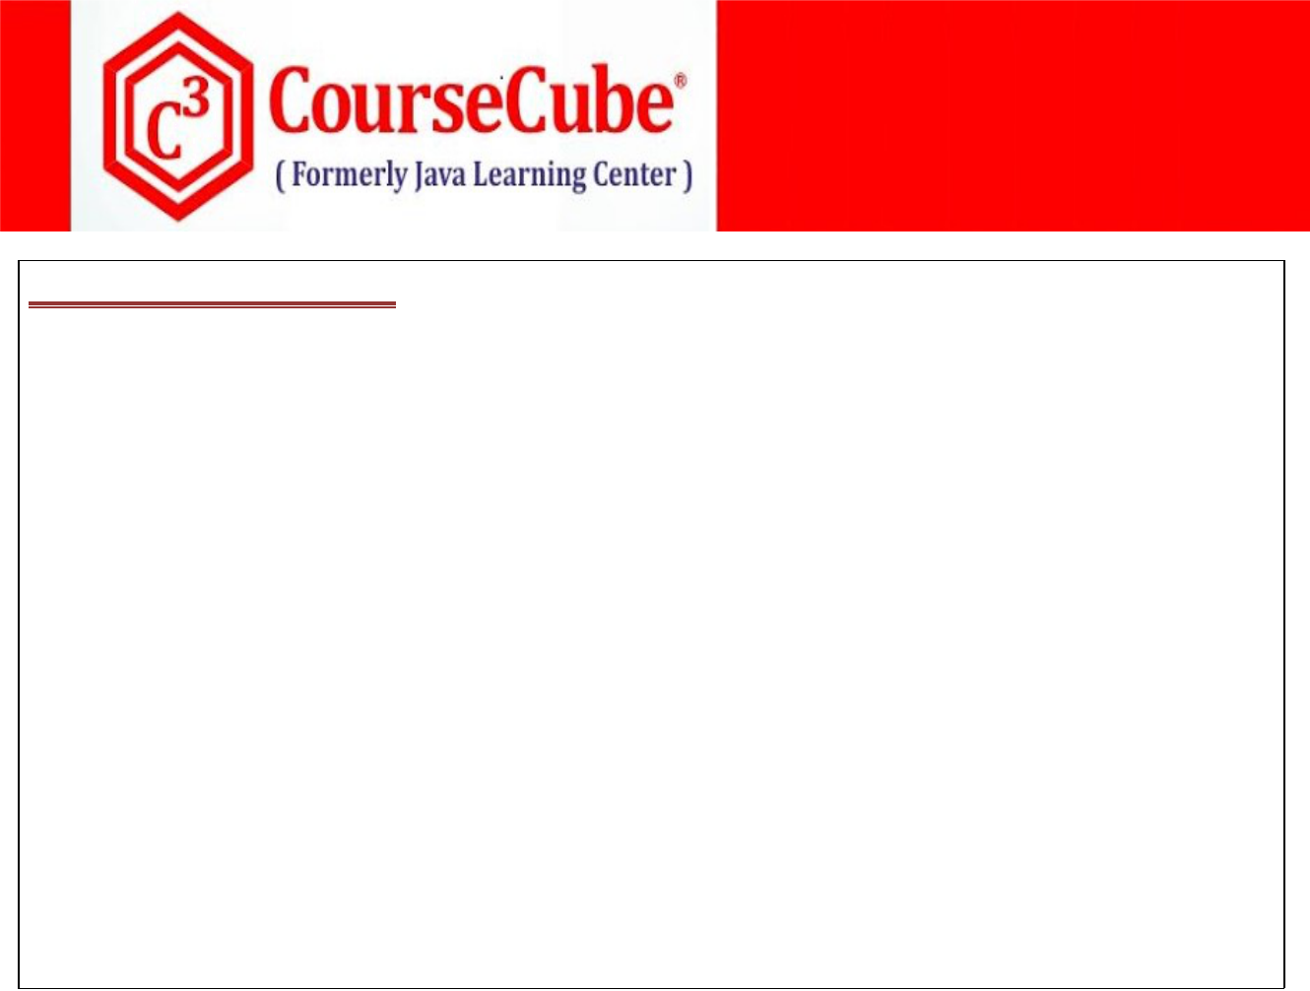

1. **JLCAppConfig.java package com.coursecube.spring;**

**import java.util.*;**

**import org.springframework.context.annotation.Bean;**

**import org.springframework.context.annotation.Configuration; /\***

* **@Author : Srinivas Dande**
* **@Company : CourseCube**
* **@Website : www.coursecube.com**
* **\*/**

**@Configuration**

**public class JLCAppConfig {**

**@Bean("myhello")**

**public Hello createHello(Hai hai) { //1. Dependency Hello h=new Hello();**

**h.setHai(hai); //2. Setter Injection**

**return h;**

**}**

**}**

**Lab11: Files required**



|  |  |  |
| --- | --- | --- |
| **1.** | **Lab11.java** | **Same as Lab10** |
|  |  |  |
| **2.** | **Hai.java** | **Same as Lab10** |
|  |  |  |
| **3.** | **Hello.java** | **Same as Lab10** |
|  |  |  |
| **4.** | **JLCAppConfig.java** | **Updated Here** |
|  |  |  |



1. **JLCAppConfig.java package com.coursecube.spring;**

**import java.util.*;**

**import org.springframework.context.annotation.Bean;**

**import org.springframework.context.annotation.Configuration; /\***

* **@Author : Srinivas Dande**
* **@Company : CourseCube**
* **@Website : www.coursecube.com**
* **\*/**

**@Configuration**

**public class JLCAppConfig {**

**@Bean("myhai")**

**public Hai createHai1() {**

**Hai hai=new Hai();**

**return hai;**

**}**



**www.coursecube.com** **34** **Spring-5 Study Guide**

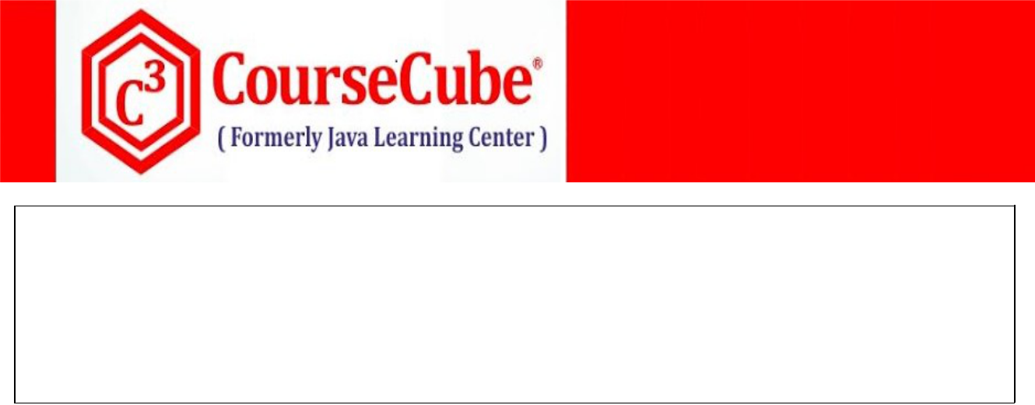

**@Bean("myhello")**

**public Hello createHello(Hai hai) { //1. Dependency Hello h=new Hello();**

**h.setHai(hai); //2. Setter Injection**

**return h;**

**}**

**}**

**Lab12: Files required**



|  |  |  |
| --- | --- | --- |
| **1.** | **Lab12.java** | **Same as Lab10** |
|  |  |  |
| **2.** | **Hai.java** | **Same as Lab10** |
|  |  |  |
| **3.** | **Hello.java** | **Same as Lab10** |
|  |  |  |
| **4.** | **JLCAppConfig.java** | **Updated Here** |
|  |  |  |



1. **JLCAppConfig.java package com.coursecube.spring;**

**import java.util.*;**

**import org.springframework.context.annotation.Bean;**

**import org.springframework.context.annotation.Configuration; /\***

* **@Author : Srinivas Dande**
* **@Company : CourseCube**
* **@Website : www.coursecube.com**
* **\*/**

**@Configuration**

**public class JLCAppConfig {**

**@Bean("myhai1")**

**public Hai createHai1() {**

**Hai hai=new Hai("I am First Bean");**

**return hai;**

**}**

**@Bean("myhai2")**

**public Hai createHai2() {**

**Hai hai=new Hai("I am Second Bean");**

**return hai;**

**}**

**@Bean("myhello")**

**public Hello createHello(Hai myhai2) { //1. Dependency Hello h=new Hello();**

**h.setHai(hai); //2. Setter Injection**

**return h;**

**}**

**}**



**www.coursecube.com** **35** **Spring-5 Study Guide**



**Lab13: Files required**



|  |  |  |
| --- | --- | --- |
| **1.** | **Lab13.java** | **Same as Lab10** |
|  |  |  |
| **2.** | **Hai.java** | **Same as Lab10** |
|  |  |  |
| **3.** | **Hello.java** | **Same as Lab10** |
|  |  |  |
| **4.** | **JLCAppConfig.java** | **Updated Here** |
|  |  |  |



1. **JLCAppConfig.java package com.coursecube.spring;**

**import java.util.*;**

**import org.springframework.context.annotation.Bean;**

**import org.springframework.context.annotation.Configuration; /\***

* **@Author : Srinivas Dande**
* **@Company : CourseCube**
* **@Website : www.coursecube.com**
* **\*/**

**@Configuration**

**public class JLCAppConfig {**

**@Bean("myhai1")**

**public Hai createHai1() {**

**Hai hai=new Hai("I am First Bean");**

**return hai;**

**}**

**@Bean("myhai2")**

**public Hai createHai2() {**

**Hai hai=new Hai("I am Second Bean");**

**return hai;**

**}**

**@Bean("myhello")**

**public Hello createHello(Hai hai) { //1. Dependency Hello h=new Hello();**

**h.setHai(hai); //2. Setter Injection**

**return h;**

**}**

**}**



**www.coursecube.com** **36** **Spring-5 Study Guide**



**AutoWiring :**

**In the case of AutoWiring, No need to specify the Bean Dependencies explicitly. Spring Container is responsbile for**

**Detecting Bean Dependencies Injecting Bean Dependencies**

**If Container is Detecting and Injecting Bean Dependencies automatically then it is called as AutoWiring.**

**There are two ways to perform AutoWiring with autowire attribute of @Bean Annotation**

* 1. **By Name Autowire Process**
  2. **By Type Autowire Process**

**Autowire enum has two constants called BY_NAME and BY_TYPE**

**@Bean(name="myhello",autowire = Autowire.BY_NAME)**

**@Bean(name="myhello",autowire = Autowire.BY_BYTE)**

**1)By Name Autowire Process**

**Container detects the Bean by Name.**

**Container checks whether any bean is found whose name is matching property name.**

**Case 1: What happens when 0 beans found.(Refer Lab14)**

**\*Bean dependency remains Un-Injected.**

**Case 2: What happens when exactly 1 bean found.(Refer Lab15)**

**Identified single bean will be injected with Setter method.**

**2)By Type Autowire Process**

**Container detects the Bean by Data Type.**

**Container checks whether any bean is found whose data Type is matching property data type.**

**Case 1: What happens when 0 beans found. (Ref.Lab16)**

**\*Bean dependency remains Un-Injected.**

**Case 2: What happens when exactly 1 bean found.(Refer Lab17)**

**Identified single bean will be Injected with setter method.**

**Case 3: What happens when two or more beans found.(Refer Lab 18)**

**Exception will be thrown**

**Caused by: org.springframework.beans.factory.NoUniqueBeanDefinitionException: No qualifying bean of type 'com.coursecube.spring.Hai' available: expected single matching bean but found 3: myhai1,myhai2,hai**



**www.coursecube.com** **37** **Spring-5 Study Guide**



**Lab14: Files required**



|  |  |  |
| --- | --- | --- |
| **1.** | **Lab14.java** | **Same as Lab10** |
|  |  |  |
| **2.** | **Hai.java** | **Same as Lab10** |
|  |  |  |
| **3.** | **Hello.java** | **Same as Lab10** |
|  |  |  |
| **4.** | **JLCAppConfig.java** | **Updated Here** |
|  |  |  |



1. **JLCAppConfig.java package com.coursecube.spring;**

**import java.util.*;**

**import org.springframework.context.annotation.Bean;**

**import org.springframework.context.annotation.Configuration; /\***

* **@Author : Srinivas Dande**
* **@Company : CourseCube**
* **@Website : www.coursecube.com**
* **\*/**

**@Configuration**

**public class JLCAppConfig {**

**@Bean("myhai")**

**public Hai createHai1() {**

**Hai hai=new Hai("I am Hai Bean");**

**return hai;**

**}**

**@Bean(name="myhello",autowire = Autowire.BY_NAME)**

**public Hello createHello() {**

**Hello h=new Hello();**

**return h;**

**}**

**}**

**Lab15: Files required**



|  |  |  |
| --- | --- | --- |
| **1.** | **Lab15.java** | **Same as Lab10** |
|  |  |  |
| **2.** | **Hai.java** | **Same as Lab10** |
|  |  |  |
| **3.** | **Hello.java** | **Same as Lab10** |
|  |  |  |
| **4.** | **JLCAppConfig.java** | **Updated Here** |
|  |  |  |



1. **JLCAppConfig.java package com.coursecube.spring;**

**import java.util.*;**

**import org.springframework.context.annotation.Bean;**

**import org.springframework.context.annotation.Configuration; /\***



**www.coursecube.com** **38** **Spring-5 Study Guide**



* **@Author : Srinivas Dande**
* **@Company : CourseCube**
* **@Website : www.coursecube.com**
* **\*/**

**@Configuration**

**public class JLCAppConfig {**

**@Bean("hai")**

**public Hai createHai1() {**

**Hai hai=new Hai("I am Hai Bean");**

**return hai;**

**}**

**@Bean(name="myhello",autowire = Autowire.BY_NAME)**

**public Hello createHello() {**

**Hello h=new Hello();**

**return h;**

**}**

**}**

**Lab16: Files required**



|  |  |  |
| --- | --- | --- |
| **1.** | **Lab16.java** | **Same as Lab10** |
|  |  |  |
| **2.** | **Hai.java** | **Same as Lab10** |
|  |  |  |
| **3.** | **Hello.java** | **Same as Lab10** |
|  |  |  |
| **4.** | **JLCAppConfig.java** | **Updated Here** |
|  |  |  |



1. **JLCAppConfig.java package com.coursecube.spring;**

**import java.util.*;**

**import org.springframework.context.annotation.Bean;**

**import org.springframework.context.annotation.Configuration; /\***

* **@Author : Srinivas Dande**
* **@Company : CourseCube**
* **@Website : www.coursecube.com**
* **\*/**

**@Configuration**

**public class JLCAppConfig {**

**@Bean(name="myhello",autowire = Autowire.BY_TYPE)**

**public Hello createHello() {**

**Hello h=new Hello();**

**return h;**

**}**

**}**



**www.coursecube.com** **39** **Spring-5 Study Guide**



**Lab17: Files required**



|  |  |  |
| --- | --- | --- |
| **1.** | **Lab17.java** | **Same as Lab10** |
|  |  |  |
| **2.** | **Hai.java** | **Same as Lab10** |
|  |  |  |
| **3.** | **Hello.java** | **Same as Lab10** |
|  |  |  |
| **4.** | **JLCAppConfig.java** | **Updated Here** |
|  |  |  |

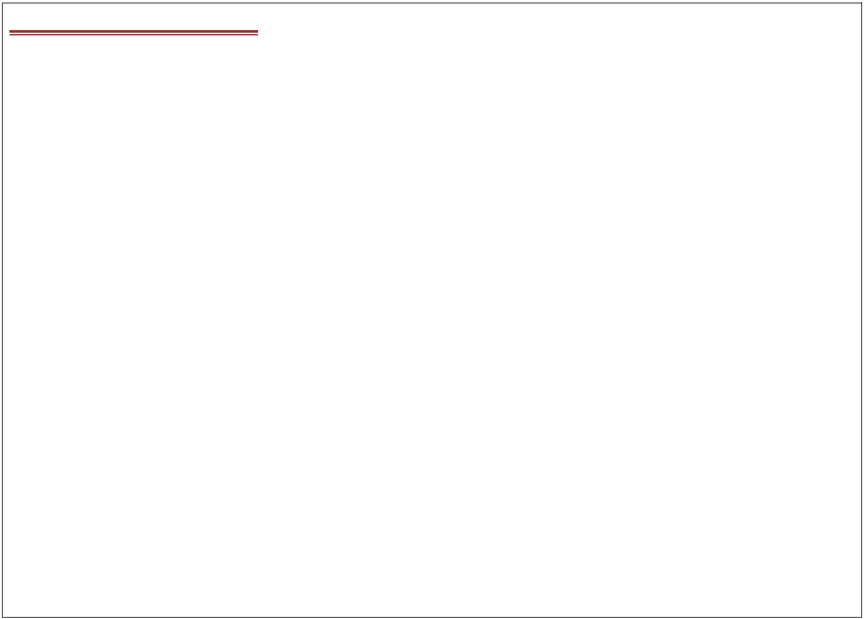

1. **JLCAppConfig.java package com.coursecube.spring;**

**import java.util.*;**

**import org.springframework.context.annotation.Bean;**

**import org.springframework.context.annotation.Configuration; /\***

* **@Author : Srinivas Dande**
* **@Company : CourseCube**
* **@Website : www.coursecube.com**
* **\*/**

**@Configuration**

**public class JLCAppConfig {**

**@Bean("myhai")**

**public Hai createHai1() {**

**Hai hai=new Hai("I am Hai Bean");**

**return hai;**

**}**

**@Bean(name="myhello",autowire = Autowire.BY_TYPE)**

**public Hello createHello() {**

**Hello h=new Hello();**

**return h;**

**}**

**}**

**Lab18: Files required**



|  |  |  |
| --- | --- | --- |
| **1.** | **Lab18.java** | **Same as Lab10** |
|  |  |  |
| **2.** | **Hai.java** | **Same as Lab10** |
|  |  |  |
| **3.** | **Hello.java** | **Same as Lab10** |
|  |  |  |
| **4.** | **JLCAppConfig.java** | **Updated Here** |
|  |  |  |



1. **JLCAppConfig.java package com.coursecube.spring;**

**import java.util.*;**

**import org.springframework.context.annotation.Bean;**

**import org.springframework.context.annotation.Configuration; /\***

**\* @Author : Srinivas Dande**



**www.coursecube.com** **40** **Spring-5 Study Guide**



* **@Company : CourseCube**
* **@Website : www.coursecube.com**
* **\*/**

**@Configuration**

**public class JLCAppConfig {**

**@Bean("myhai1")**

**public Hai createHai1() {**

**Hai hai=new Hai("I am First Hai Bean");**

**return hai;**

**}**

**@Bean("myhai2")**

**public Hai createHai2() {**

**Hai hai=new Hai("I am Second Hai Bean");**

**return hai;**

**}**

**@Bean("hai")**

**public Hai createHai3() {**

**Hai hai=new Hai("I am Third Hai Bean");**

**return hai;**

**}**

**@Bean(name="myhello",autowire = Autowire.BY_TYPE)**

**public Hello createHello() {**

**Hello h=new Hello();**

**return h;**

**}**

**}**



**Injecting Sub Types into Super Types.**

**Lab19: Files required**



|  |  |  |  |
| --- | --- | --- | --- |
| **1.** | **Lab19.java** | **2.** | **A.java** |
|  |  |  |  |
| **3.** | **B.java** | **4.** | **CustomerDAO.java** |
|  |  |  |  |
| **5.** | **CustomerDAOImpl.java** | **6.** | **Hello.java** |
|  |  |  |  |
| **7.** | **JLCAppConfig.java** |  |  |
|  |  |  |  |



**1. Lab19.java**

**package com.coursecube.spring;**

**import org.springframework.context.ApplicationContext;**

**import org.springframework.context.annotation.AnnotationConfigApplicationContext; /\***

* **@Author : Srinivas Dande**
* **@Company : CourseCube**



**www.coursecube.com** **41** **Spring-5 Study Guide**

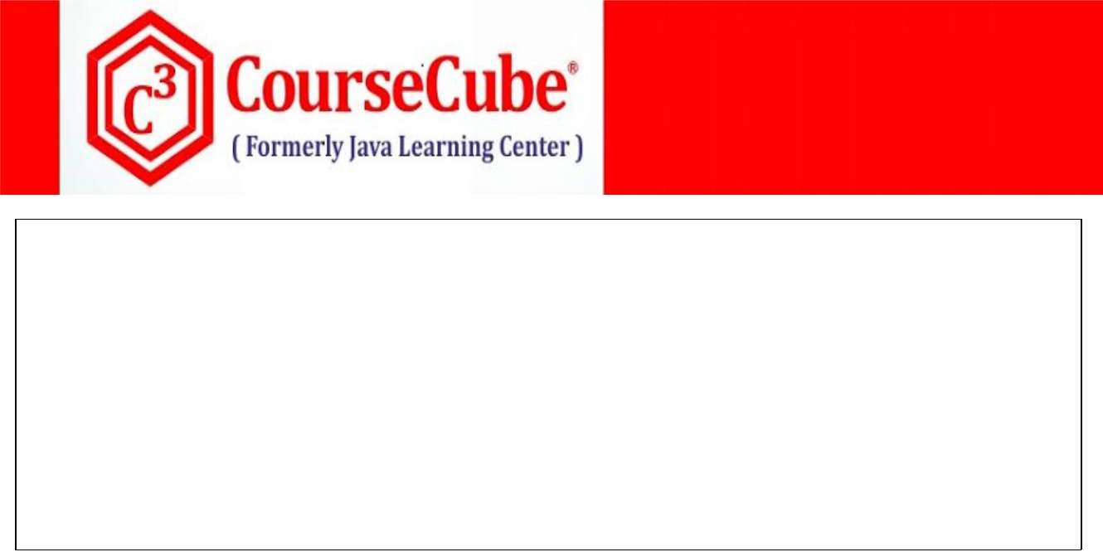

* **@Website : www.coursecube.com**
* **\*/**

**public class Lab19 {**

**public static void main(String[] args) {**

**ApplicationContext ctx=new AnnotationConfigApplicationContext(JLCAppConfig.class); System.out.println("---------Now Spring Container is Ready-----");**

**Hello hello=(Hello)ctx.getBean("myhello");**

**hello.show();**

**}**

**}**



**2. A.java**

**package com.coursecube.spring;**

**/\***

* **@Author : Srinivas Dande**
* **@Company : CourseCube**
* **@Website : www.coursecube.com**
* **\*/**

**public class A {**

**public String toString() {**

**return "I am Bean A";**

**}**

**}**



**3. B.java**

**package com.coursecube.spring;**

**/\***

* **@Author : Srinivas Dande**
* **@Company : CourseCube**
* **@Website : www.coursecube.com**
* **\*/**

**public class B extends A{**

**public String toString() {**

**return "I am Bean B";**

**}**

**}**



**4. CustomerDAO.java**

**package com.coursecube.spring;**

**/\***

* **@Author : Srinivas Dande**
* **@Company : CourseCube**
* **@Website : www.coursecube.com**
* **\*/**

**public interface CustomerDAO {**

**public void addCustomer();**

**}**



**www.coursecube.com** **42** **Spring-5 Study Guide**



**5. CustomerDAOImpl.java**

**package com.coursecube.spring;**

**/\***

* **@Author : Srinivas Dande**
* **@Company : CourseCube**
* **@Website : www.coursecube.com**
* **\*/**

**public class CustomerDAOImpl implements CustomerDAO { @Override**

**public void addCustomer() {**

**System.out.println("----AddCustomer---");**

**}**

**}**



**6. Hello.java**

**package com.coursecube.spring;**

**/\***

* **@Author : Srinivas Dande**
* **@Company : CourseCube**
* **@Website : www.coursecube.com**
* **\*/**

**public class Hello {**

**A aobj; //1**

**CustomerDAO customerDAO; //2**

**public void setAobj(A aobj) {**

**this.aobj = aobj;**

**}**

**public void setCustomerDAO(CustomerDAO customerDAO) { this.customerDAO = customerDAO;**

**}**

**public void show() {**

**System.out.println(aobj);**

**customerDAO.addCustomer();**

**}**

**}**



1. **JLCAppConfig.java package com.coursecube.spring;**

**import org.springframework.beans.factory.annotation.Autowire; import org.springframework.context.annotation.Bean;**

**import org.springframework.context.annotation.Configuration; /\***

* **@Author : Srinivas Dande**
* **@Company : CourseCube**
* **@Website : www.coursecube.com**



**www.coursecube.com** **43** **Spring-5 Study Guide**



* **\*/**

**@Configuration**

**public class JLCAppConfig { /* @Bean("ao") public A createA() {**

**return new A();**

**}**

**\*/**

**@Bean(name="bo") public B createB() {**

**return new B();**

**}**

**@Bean(name="cdao")**

**public CustomerDAO getCustDAO() { return new CustomerDAOImpl();**

**}**

**@Bean(name="myhello",autowire = Autowire.BY_TYPE) public Hello createHello() { //Hello Bean**

**return new Hello();**

**}**

**}**



**Cyclic Dependency Injection:**

**Spring Supports Cyclic DI with Setter Injection.**

**Spring does not support Cyclic DI with Constrcutor Injection.**

**Lab20: Files required**



|  |  |  |  |
| --- | --- | --- | --- |
| **1.** | **Lab20.java** | **2.** | **Hai.java** |
|  |  |  |  |
| **3.** | **Hello.java** | **4.** | **JLCAppConfig.java** |
|  |  |  |  |



**1. Lab20.java**

**package com.coursecube.spring;**

**import org.springframework.context.ApplicationContext;**

**import org.springframework.context.annotation.AnnotationConfigApplicationContext; /\***

* **@Author : Srinivas Dande**
* **@Company : CourseCube**
* **@Website : www.coursecube.com**
* **\*/**

**public class Lab20 {**

**public static void main(String[] args) {**

**ApplicationContext ctx=new AnnotationConfigApplicationContext(JLCAppConfig.class); System.out.println("---------Now Spring Container is Ready-----"); }**

**}**



**www.coursecube.com** **44** **Spring-5 Study Guide**



**2. Hai.java**

**package com.coursecube.spring;**

**/\***

* **@Author : Srinivas Dande**
* **@Company : CourseCube**
* **@Website : www.coursecube.com**
* **\*/**

**public class Hai {**

**Hello hello; //Dependency**

**public Hai() {**

**System.out.println("Hai-D.C");**

**}**

**public void setHello(Hello hello) { //Setter Injection System.out.println("Hai - setHello()"); this.hello = hello;**

**}**

**}**



**3. Hello.java**

**package com.coursecube.spring;**

**/\***

* **@Author : Srinivas Dande**
* **@Company : CourseCube**
* **@Website : www.coursecube.com**
* **\*/**

**public class Hello {**

**Hai hai; //Dependency**

**public Hello() {**

**System.out.println("Hello-D.C");**

**}**

**public void setHai(Hai hai) { //Setter Injection System.out.println("Hello-setHai()"); this.hai = hai;**

**}**

**}**



**www.coursecube.com** **45** **Spring-5 Study Guide**

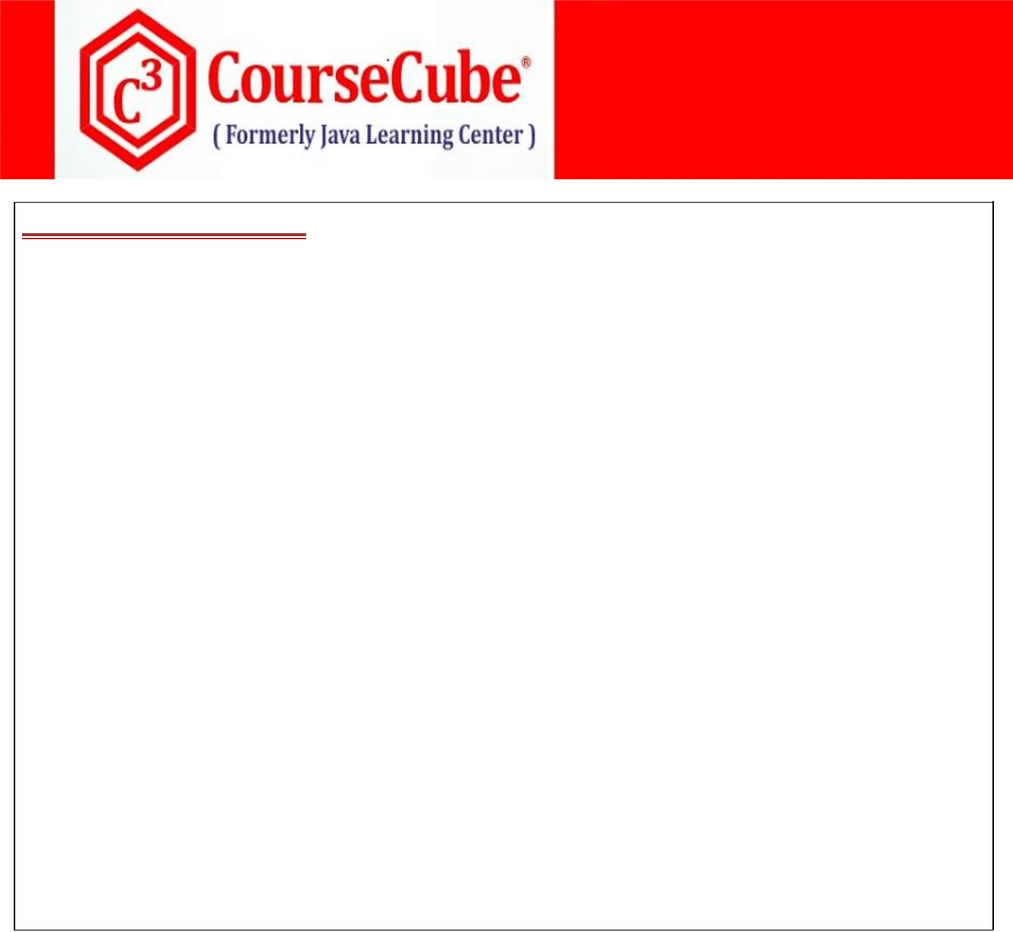

1. **JLCAppConfig.java package com.coursecube.spring;**

**import org.springframework.beans.factory.annotation.Autowire; import org.springframework.context.annotation.Bean;**

**import org.springframework.context.annotation.Configuration; /\***

* **@Author : Srinivas Dande**
* **@Company : CourseCube**
* **@Website : www.coursecube.com**
* **\*/**

**@Configuration**

**public class JLCAppConfig {**

**@Bean(name="myhai",autowire = Autowire.BY_TYPE)**

**public Hai createHai() {**

**Hai hai=new Hai();**

**return hai;**

**}**

**@Bean(name="myhello",autowire = Autowire.BY_TYPE)**

**public Hello createHello() {**

**Hello hello=new Hello();**

**return hello;**

**}**

**}**



**www.coursecube.com** **46** **Spring-5 Study Guide**